

PROSENSE PPS-RCO Series Gas Detectors Installation and User Manual

WARNING!

This manual must be carefully read by all persons who have or will have the responsibility for installing, using or servicing this product.

Like any equipment, this product will perform as designed only if installed, used and serviced in accordance with the manufacturer’s instructions. Otherwise, it could fail to perform as designed and persons who rely on this product for their safety could suffer severe personal injury or death.

The warranties made by Prosense with respect to this product are voided if the product is not installed, used and serviced in accordance with the instructions in this user guide. Please protect yourself and other by following them.

Important Remark
The detector has been factory-tested before delivery, the commissioning after installation must include the zero- and span-adjustment. The commissioning has to be terminated by a function test of the complete gas detection system.

CONTENTS
For Your Safety 4
Strictly Follow The Instructions for Use 4
Use In Areas Subject To Explosion Hazards 4
Liability For Proper Function Or Damage 4
Intended Use 4
Introduction 5
Detector Body 5
Sensor Head 6
Installation 6
Mounting The Detector 7
Cabling and Connections 8
Detector Connections 9
Detectors Connections with RS485 Module 10
System Status 12
First time switch on (Commissioning) 12
Calibration 12
Zero Calibration 12
Span Calibration 13
General Specification 14
Warranty Statement 15

For Your Safety
Ensure that this Operating Manual is read and understood BEFORE installing / operating / maintaining the equipment. Pay particular attention to Warnings and Cautions. All document Warnings are listed here and repeated where appropriate at the start of the relevant chapter(s) of this Operating Manual. Cautions appear in the sections/sub-sections of the document where they apply.

Strictly Follow The Instructions for Use
Any use of the detectors requires full understanding and strict observation of these instructions. The detector is only to be used for purposes specified here.

Use In Areas Subject To Explosion Hazards
Equipment or components which are used in potentially explosive atmospheres and have been tested and approved according to International or European regulations may be used only under the conditions specified here. Modifications of components or the use of faulty or incomplete parts are not permitted. In case of repairs of equipment or components, the national regulations must be observed.

Liability For Proper Function Or Damage
The liability for the proper function of the detector is irrevocably transferred to the owner or operator to the extent that the detector is serviced or repaired by personnel not employed or authorized by Prosense or if the sensing head is used in a manner not conforming to its intended use. Prosense cannot be held responsible for damage caused by non-compliance with the recommendations given above. The warranty and liability provisions of the terms of sale and delivery of Prosense are likewise not modified by the recommendations given above.

Intended Use
The PPS-RCO series detectors are intended to be used for stationary, continuous monitoring for CO gas in 0-300 ppm range under atmospheric conditions. PPS-RCO Series detectors are suitable to use in safe areas.
Not to be used in oxygen enriched atmospheres
In conjunction with the central controllers Prosense detectors with preadjusted
alarm thresholds audible and visible alarm devices or automatic countermeasures
can be activated before the detected gases or vapours can form dangerous
mixtures with air.

If a gas alarm occurs, necessary actions need to be taken immediately. The decrease of the measuring signal should not mean that the gas concentration has been decreased. We recommend to keep alarms on the associated controllers and not to reset these alarms without performing measurement with an independent gaz detectors to make sure conditions are safe.

Introduction

The Prosense PPS-RCO comprises a gas detector body and an electrochemical sensor heads for detecting CO toxic gas. The construction of Prosense allows it to be used in non-hazardous safe area locations.

Prosense PPS-RCO detector provides three programmable relays which are FAULT, ALARM1 and ALARM2 for controlling external equipment e.g. alarms, sirens, valves or switches. The detector can be configured to communicate RS485 modbus protocal with an optional module and also provides FAULT and ALARM1 relay outputs at same time.

Detector Body

Prosense PPS-RCO series detectors comprises of the main parts as shown below:
Cable entries
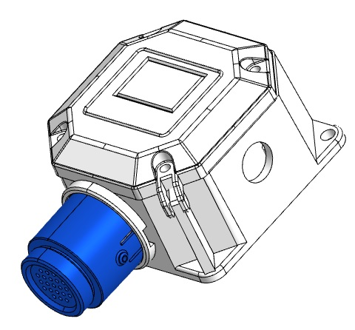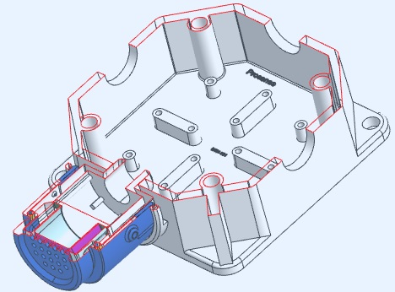
Body Cover
Dedector body
Sensor entry
Sensor Head

Diagram 1: Exploded view

The detector enclosure has four threaded entries. The three cable entries either side of the upper part of the transmitter housing are for connecting the power source, signal output and relay contacts to associated signalling equipment. The bottom entry allows direct connection of the sensor socket. The body has integrated mounting screw locations on housing.
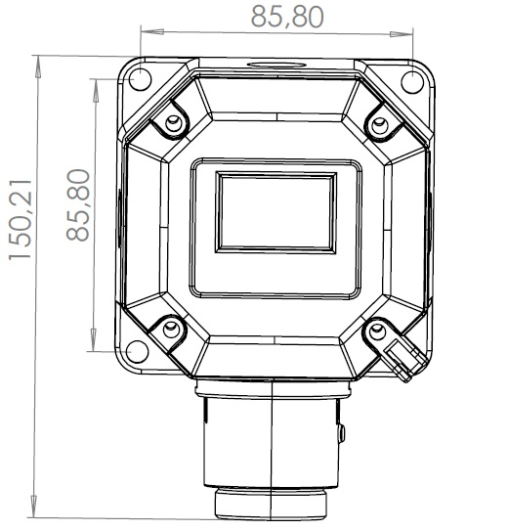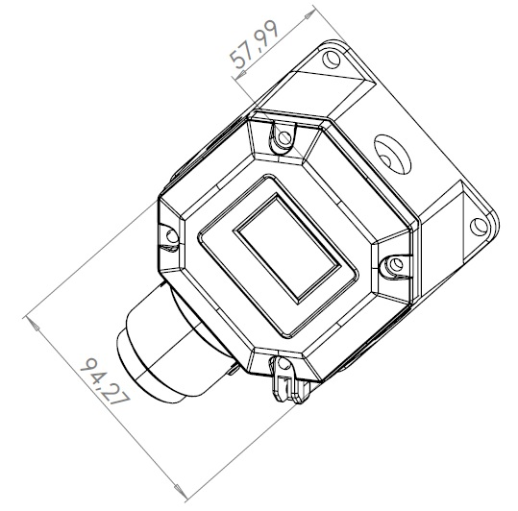
Diagram 2: Detector Body and Sensor Head Size

Sensor Head
The Prosense PPS-RCO series sensor head designed to dedect toxic gases. Sensor head includes a wide range of toxic gas sensors based on electrochemical cell (ECC) technology.

Installation
Gas detectors should be mounted where a potential hazard of gas is most likely to be present. The following points should be noted when locating gas sensors.

- When locating detectors consider the possible damage caused by natural events e.g. rain or flooding.
- Consider ease of access to the gas detector for functional testing and servicing.
- Consider how escaping gas may behave due to natural or forced air currents.

Note: The placement of gas detectors should be determined following the advice of experts having specialist knowledge of gas dispersion, experts having knowledge of the process plant system and equipment involved, safety and engineering personnel. The agreement reached on the location of detectors should be recorded.

Each gas has different nature depending on their density. The density of which is lower than air, such as hydrogen, methane or ammonia the sensor head must be located above a possible leak or at the highest points at which major concentrations of gas may be found. The gases and vapours with a density greater than air, the sensor head must be installed beneath a possible leak or at the lowest points at which such gases and vapours may be present. The density of which is higher than air the sensor head must be located where gas accumulate.

Mounting The Detector

The detector should be mounted vertically as the sensor head pointing downwards. Detector has to be mounted such that the sensor's gas entrance area.

The install location
- should be isolated from vibration, direct sun light and have temperature stability
- avoided external influences such as splashing water, oil, corrosive aerosols
- should have at least 30 cm free space beneath the sensor head to provide accessibility for calibration work.
- should be in air flow between possible leak or collection point and possible source of ignition.

Prosense do not recommend to install detectors to :
- directly above a cooking unit,
- directly above a sink unit,
- close to an extractor unit,
- outdoor without protection against the rain,
- in places where temperature is outside the admissible operating range,
- in corrosive environments,
- inside air vents.
- in environments where silicon can be found.

The Prosense detector has an integrated mounting screw holes on the body. The correct mounting position is given in Diagram 3:

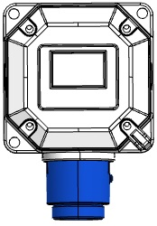
Mounting hole
Mounting hole
Mounting hole
Diagram 3: Mounting holes on body

Cabling and Connections
Caution: All electrical connections should be made in accordance with any relevant local or national legislation, standards or codes of practice.

Prosense PPS-RCO series detectors can operate between 12 - 24 VDC. The connection socket located on main board. User should consider the cable lenght when performing installation in the field. The Prosense detector requires a power supply between 12VDC and 24VDC. Make sure that a minimum 12 VDC supply available at the detector entrance and consider the voltage drop due to cable resistance in case of long distance applications.

The use of industrial grade, suitably shielded field cable is recommended. The best practices shown that, screened 4 cores (plus screen 90% coverage), suitably mechanically protected copper cable with a suitable explosion-proof gland, or ¾” NPT steel conduit, depending on the distance between signal received or control panel and detector. It is recommended to use 1.5 mm2 (16 AWG) cable.

V+, V-(GND) ports must be connected via using two-wire cable to supply 16VDC power to detector. If detector has RS485 communication module additional two wire cable should be used to connect A and B to read the output signal of detector from A and B ports. Connections should be made correctly with extra care to do not mix ports and not cause any damage on the detectors. Detector power connection should be done with 1.5mm2 cross section cable. The total distance between control panel and detectors should not exceed 1km.

The wiring for detectors utilized with RS485 board should be done by using connection cable EIA RS485 2 core wires with section 0.22 / 0.35 mm2 and shielded. Nominal capacity between the wires < 50pF/m and nominal impedance 120 Ohms.

In case RS485 communciation module used on detectors to monitor through DP32 control panel, the V+, V- ports and A,B ports are located on different socket in both DP32 control panel and detector side. The connections should be done with care to do not mix power and RS485 ports. All detectors will be connected through one cable via hopping one detector to another till the last detector on the line.
There should be one master device and up to 32 slave devices in RS485 communication. The master is DP32 control panel and detectors will be the slave devices:

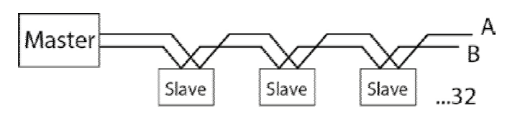
Diagram 4: RS485 communication

Detector 1
Detector 2
A
B
V-
V+
DP32
Panel
Max 32
Detector
V+ V- B A
V+ V- B A
A
B
V-
V+

Diagram 5: Panel to detector connections
Each detector connected to DP32 panel should have unique address. Detectors having same address would not be recognised by control panel. DP32 panel can communicate up to 32 detectors. In case less then 32 detectors connected, control panel would not show non-existent detectors. Unused detectors should be deactivated on channel settings menu steps.
Important: The last detector at the communication line should have line termination resistor (120 Ohm) to enable communication for all detectors on the line. The resistor is not implemented on the board and user should connect it physically during the installation.

Detector Connections
PPS-RCO Series detectors has a power input and three relay output sockets on main board:
Address and alarm level adjustment switches
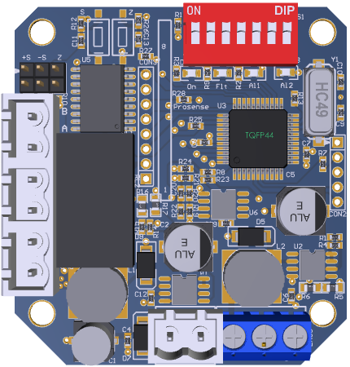
Status LEDs
Power Fault Alarm1 Alarm2
V-
Sensor connection
ALARM1
ALARM2
FAULT
V+
Diagram 6: PPS-RCO Series detector main board
PPS-RCO Serisi detectors has three integrated relays on main board which are named as Alarm1, Alarm2 and Fault. Relays are not energised and only works as NO (Normally Open) status. It is not possible to adjust relay activation method. Alarm1 relay will be activated when alarm1 threshold level exceeded. If Alarm2 threshold level reached while Alarm 1 relay was active, Alarm2 relay will be activated with Alarm1 relay. Fault relay will be activated only on fault conditions. Alarm levels are adjustable to predefined levels. Switches 6 and 7 should be used to change alarm levels.
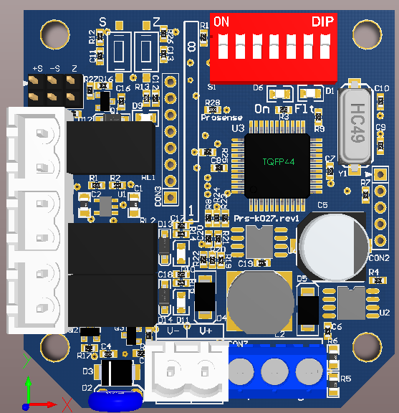
Alarm level adjustment switches
Diagram 7: PPS-RCO Series detector alarm level adjustment switches
Alarm levels and related switch positions are given in table-3:
Switch 6 | Switch 7 | Alarm1 | Alarm2
OFF | OFF | 20 | 30
OFF | ON | 20 | 50
ON | OFF | 20 | 60
ON | ON | 20 | 100
Table 1: PPS-RCO Series detector alarm levels

Detector Connections with RS485 Module
When RS485 module installed on PPS-RCO series detectors the ALARM2 relay ports will be converted to RS485 ports automatically. The detector can still provide fault and alarm relays with RS485 communication module.
RS485 Communication module slot
Address and alarm level adjustment switches
RS485-B
RS485-A
Status LEDs
Power Fault Alarm1 Alarm2
V-
Sensor connection
ALARM1
FAULT
V+
Diagram 8: PPS-RCO Series detector with RS485 module
Important: The last detector at the communication line should have line termination resistor (120 Ohm) to enable communication for all detectors on the line. The resistor is not implemented on the board and user should connect it physically during the installation.

PPS-RCO series detector main board has a dip-switch to assign address to the detector. Each detector must have unique address to communicate to DP32 Panel. Detectors having same address would not be recognised by the panel. The address should be set via using first 5 switches on the dip-switch.
Address switches
Diagram 9: Detector address switches
The wiring for detectors utilized with RS485 board should be done by using connection cable EIA RS485 2 core wires with section 0.22 / 0.35 mm2 and shielded. Nominal capacity between the wires < 50pF/m and nominal impedance 120 Ohms. Detectors will be wired in daisy chain (bus) mode. We recommend not to use star mode connection due to negative impact of interference. Each detector should have uniqe address number in the chain. The detectors would not be recognised by control panel if same address given to them. The address of detector can be adjusted via using DIP-Switch set on the board: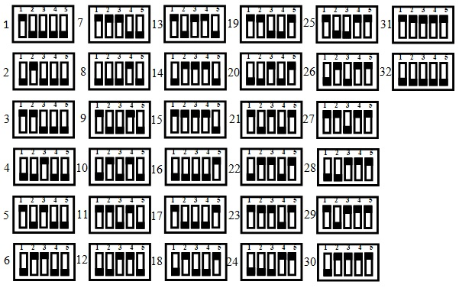
Diagram10: RS485 Modbus serial communication address and switch position
Important : Only the last detector on the serial bus should have end of line resistor.

System Status
Prosense PPS-RCO Series detectors has four LEDs on main board. Power LED (green) shows system power status and yellow LED shows fault status. Fault relay will be activated and Fault LED (yellow) will start flashing right after power applied. After appoximitly 90 sec the yellow LED will be turned of and only power LED (green) will start blinking. This status means that detector is ready to normal operation. In case of fault power LED (green) will contiune blinking and fault LED (yellow) will be lit solid. The alarm LEDS (red) will be activated when detector measures gas level at alarm thresholds and also activate related alarm LEDs.

First time switch on (Commissioning)
WARNING
The following procedure requires the detector cover to be removed while carrying out supply voltage checks. Therefore the appropriate permits to work should be sought in preparation. Prior to carrying out any HOT WORK ensure local and site procedures are followed. Ensure that the associated control panel output actuation is inhibited so as to prevent false alarms.
Caution: The following procedure should be followed carefully and only performed by suitably trained personnel

- Remove the detector cover
- Make sure the detector's output and power input connections done correctly
- Check that all electrical connections are terminated correctly
- Switch On the external power supply to feed the detector. If it is connected to DP32 Panel, cables should be installed according to DP32 Panel user manual as panel can provide both power and communication connections to the detectors.
- Using a Digital Multi Meter (DMM), check the Supply Voltage at the terminals V+ and V- this should be a minimum supply voltage of 12VDC (Maximum supply voltage is 24VDC).
- Check LED status on detector main board. LED status should be like explained above after appying power.
- Wait two minutes and confirm detector LED status pointing normal operation. If detectors used with DP32 Panel, panel should recognise each detector correctly at their addresses.
- Switch Off the external power to the detector.
- Fit the cover and make sure non of the cables cause an obstruction while fitting cover
- Switch on external power to the detector or panel if used.

Calibration
It is recommended to periodically carry out calibration to ensure correct operation. Calibration should be done by a person who trained and certified by local or international authorities.
Detector should be powered and stabilized for at least 30 minutes before calibration. To calibrate the detector, use an appropriate span gas cylinder, constant flow regulator and Prosense Gas Cap. The flow rate used for calibration gas is 0.5 L/Min.

Zero Calibration
It is recommended to use a compressed air cylinder (20.9%Vol oxygen) to perform the zero calibration if the area where the detector is located contains any residual amount of the target gas. If no residual gas is present then the background air can be used to perform the zero calibration. To perform Zero calibration put a jumper to Z pins on detector main board and press Zero button for 3 seconds. The zero level will be automatically adjusted.

Span Calibration
As there is only relay outputs and RS485 communication ports available on detector it is necessary to use a control panel to see gas measurement of the detector during the span calibration. If RS485 communication is not possible calibration should be done in a service center. To perform Span calibration apply gas to detector via using the Gas Cap while detector is energised and working. The signal level vary depending on the used gas for calibration and gas concentration. If the measured level is lower than the calibration gas level, put a jumper to S+ pin press to Span button till the level reaches the necessarly value. If the measurement level is higher than the necessary value, put a jumper to S- pin and press to Span button till the level reaches the necessarly value. Once the span calibration completed remove the jumper and put as a spare on to detector board.
Important: Never put jumper on both S+ and S- pins and press any button.
Span (S+ , S-) and Zero (Z) pins
Span (S) and Zero (Z) buttons
Diagram 11: Calibration buttons and pins

General Specification
PPS-RCO Series Detector Electrical Specifications:
Input Voltage Range | 12 to 20VDC (16VDC nominal)
Max Power Consumption | 0.96 Watts at 16VDC - normal condition
 | 1.60 Watts at 16VDC - alarm and fault condition
Terminals | 4 x 2 x screw terminals suitable for wire diameter 1.5mm2 to 2.5mm2
Relays | 3 x (1A 30VDC, 0.5A 125VAC, 0.3A 80VDC).  Non-selectable: normally open and de-energized
Communication | RS485, Modbus RTU
Sensor | Electrochemical
Table 2: PPS-RCO Series detectors electrical specifications
Detector Body Specifications:
Material | Plastic (black)
Weight | Plastic buat: 230g (with Sensor Header)
Mounting | Wall mounting
Entries | PG11
Table 3: Detector body specifications
Environmental:
IP Rating | IP54 (plastic buat)
Operating Temperature | -10ºC to +50ºC / 14ºF to +120ºF
Operating Humidity | Continuous 20-90%RH (non condensing)
Operating Pressure | 90-110kPa
Storage Conditions | -10°C to +50°C (14°F to +120°F)
Table 4: Environmental specifications

Warranty Statement
All products are designed and manufactured to the latest internationally recognized standards by Prosense Technology under a Quality Management system that is certified to ISO 9001. As such Prosense Technology warrants its products against defective parts and workmanship and will repair or (at its option) replace any instruments which are or may become defective under proper use within 12 months from date of commissioning by an approved Prosense Technology representative or 18 months from date of shipment from Prosense Technology, whichever is the sooner. This warranty does not cover disposable batteries or damage caused by accident, abuse, abnormal operating conditions or poisoning of sensor.

Defective goods must be returned to Prosense Technology premises accompanied by a detailed description of any issue. Where return of goods is not practicable Prosense Technology reserves the right to charge for any site attendance where any fault is not found
with he the equipment. Prosense Technology shall not be liable for any loss or damage whatsoever or howsoever occasioned which may be a direct or indirect result of the use or operation of the Contract Goods by the Buyer or any Party.

This warranty covers instrument and parts sold to the Buyer only by authorized distributors, dealers and representatives as appointed by Prosense Technology. The warranties set out in this clause are not pro rata, i.e. the initial warranty period is not extended by virtue of any works carried out there under.

In no event will Prosense Technology be liable for any incidental damages, consequential damages, special damages, punitive damages, statutory damages, indirect damages, loss of profits, loss of revenues, or loss of use, even if informed of the possibility of such damages. Prosense Technology's liability for any claims arising out of or related to this product will in no case exceed the order value. To the extent permitted by applicable law, these limitations and exclusions will apply regardless of whether liability arises from breach of contract, warranty, tort (including but not limited to negligence), by operation of law, or otherwise.

